 | Classic Models, Inc.
  701 Gateway Boulevard, San Francisco, CA 94107
  Top 5 / Top 25% Customers by Revenue

Top 5 Customers

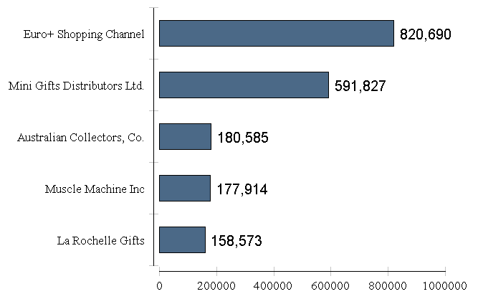

Top 25% Customers (sorted by name)

Customer Name | Customer Number | Customer Total
AV Stores, Co. | 187 | $148,410.09
Anna's Decorations, Ltd | 276 | $137,034.22
Australian Collectors, Co. | 114 | $180,585.07
Corporate Gift Ideas Co. | 321 | $132,340.78
Corrida Auto Replicas, Ltd | 458 | $112,440.09
Danish Wholesale Imports | 145 | $129,085.12
Down Under Souveniers, Inc | 323 | $154,622.08
Dragon Souveniers, Ltd. | 148 | $156,251.03
Euro+ Shopping Channel | 141 | $820,689.54
Handji Gifts& Co | 166 | $107,746.75
Kelly's Gift Shop | 496 | $137,460.79
L'ordine Souveniers | 386 | $125,505.57
La Rochelle Gifts | 119 | $158,573.12
Land of Toys Inc. | 131 | $149,085.15
Mini Gifts Distributors Ltd. | 124 | $591,827.34
Muscle Machine Inc | 151 | $177,913.95
Online Diecast Creations Co. | 363 | $116,449.29
Reims Collectables | 353 | $126,983.19
Rovelli Gifts | 278 | $127,529.69
Salzburg Collectables | 382 | $137,480.07
Saveley & Henriot, Co. | 146 | $130,305.35
Scandinavian Gift Ideas | 448 | $120,943.53
Souveniers And Things Co. | 282 | $133,907.12
The Sharp Gifts Warehouse | 450 | $143,536.27
Vida Sport, Ltd | 298 | $108,777.92

